**Task 9: Compiling Maven in local server via Jenkins Executing Windows Batch Command Configuration**

1. **The Maven project folder got generated in the local server**

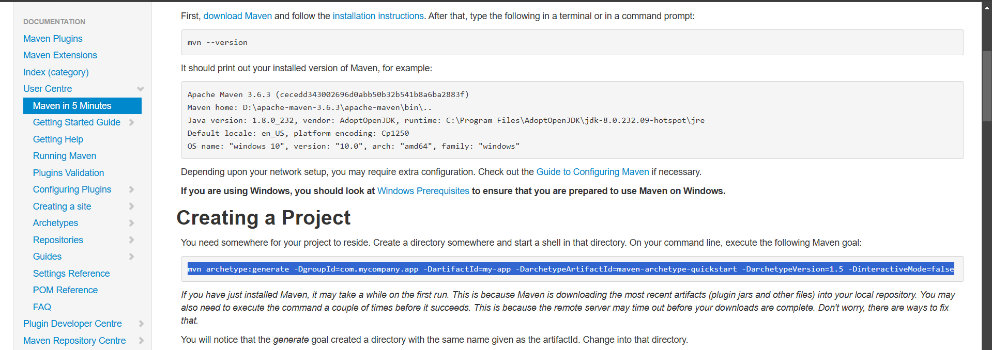

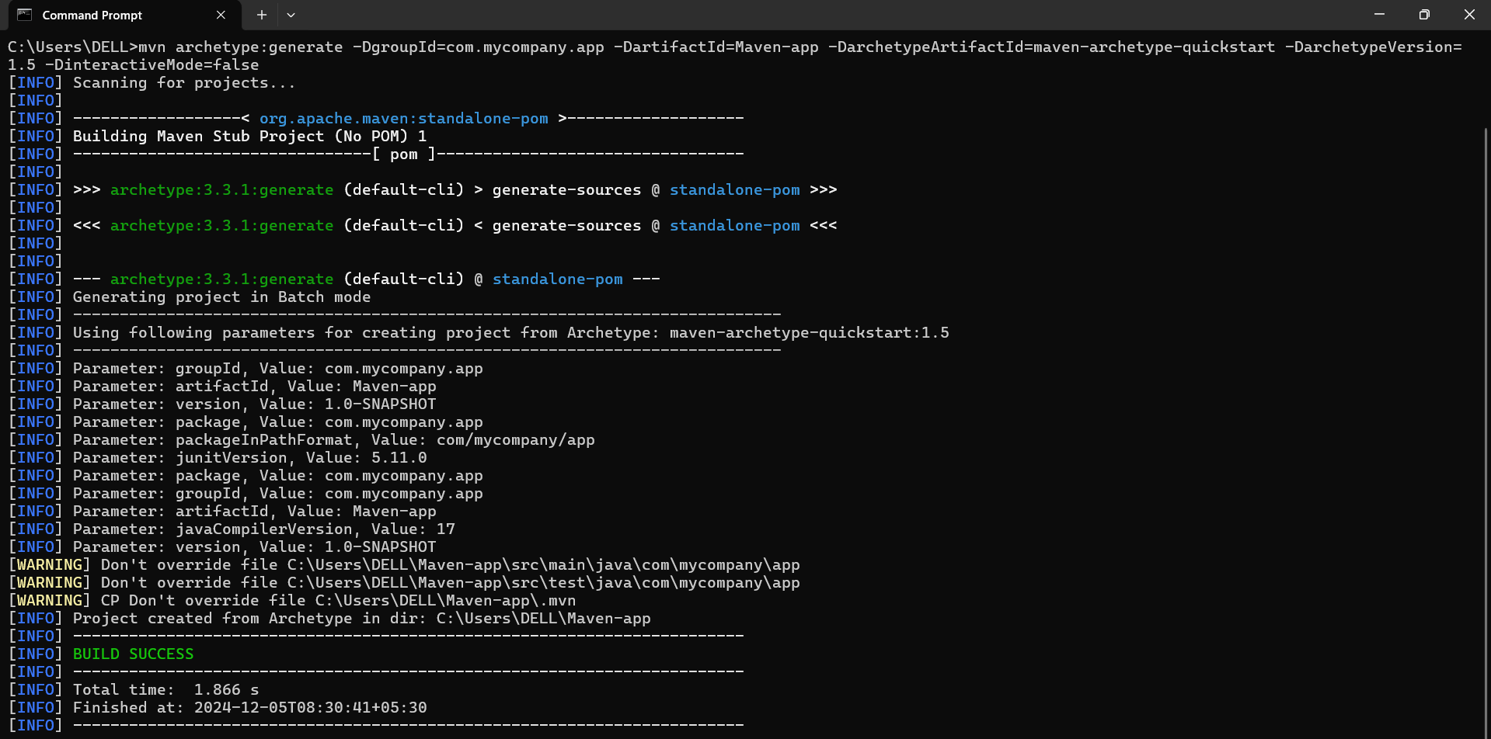

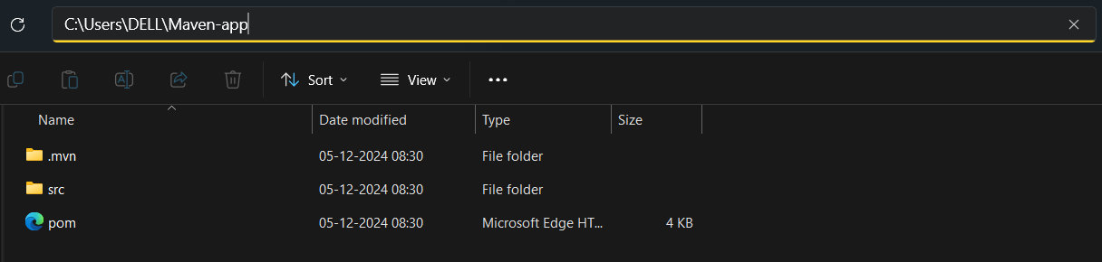

1. **Created a new job in Jenkins named “Maven_Jenkins”**

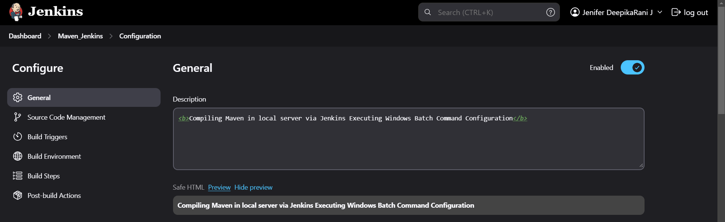

1. **Compiling the Maven project file using Execute Windows Batch Command build step**

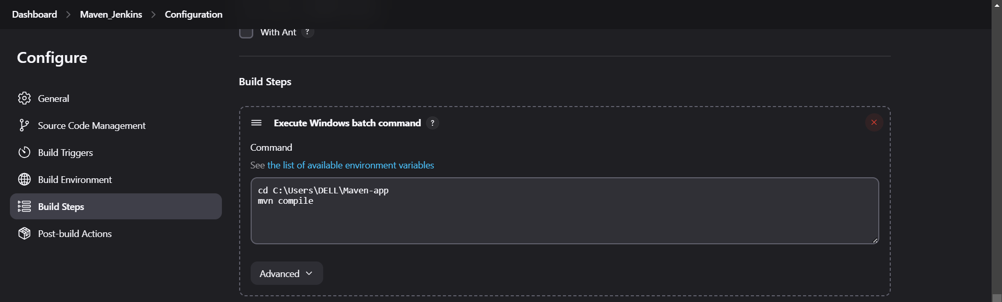

1. **Job has successfully built and here is the Console Output**

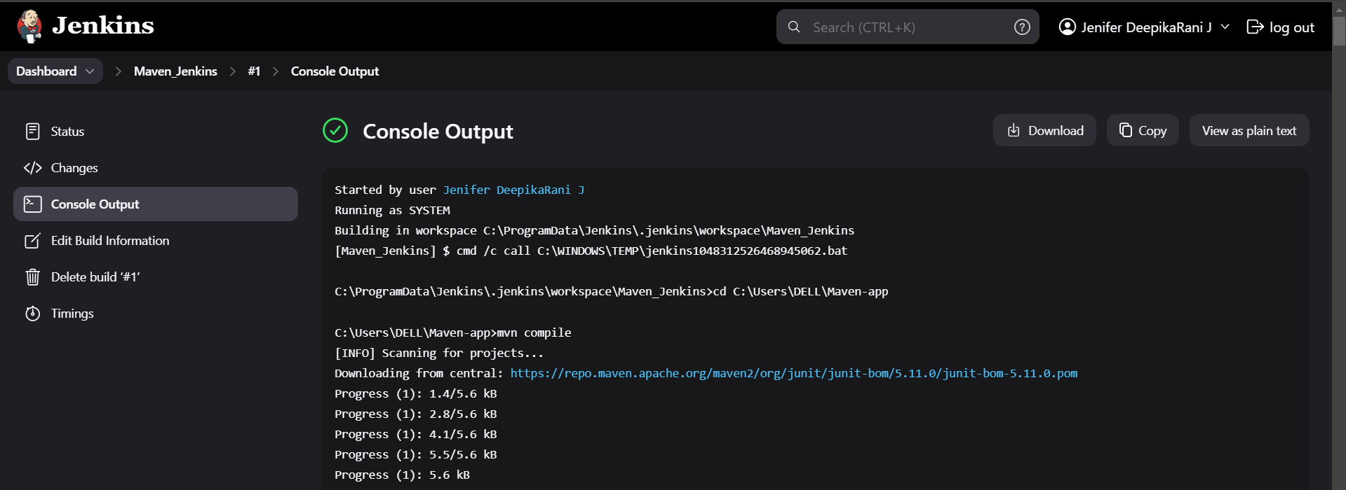

1. **The Target folder got placed the given location successfully**

